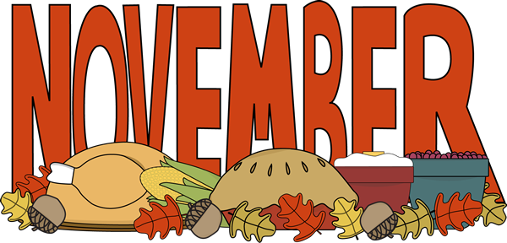
Sun | Mon | Tue | Wed | Thu | Fri | Sat
 |  |  |  |  | 1  12a-3:30p Red Ribbon Week  Wear Red- Proud to Be Drug Free | 2
3 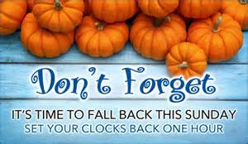 | 4  3p-4:45p STEM enrichment | 5 Election Day | 6  3p-4:45p STEM enrichment | 7  2nd Grade Field Trip | 8  4th grade Veteran's Day Program 9 or 1? | 9
10 | 11 Veterans' Day  3p-4:45p STEM enrichment | 12 | 13  3p-4:45p STEM enrichment | 14 | 15 | 16
17 | 18  3p-4:45p STEM enrichment | 19 | 20  Educational Support Professionals' Appreciation Day  3p-4:45p STEM enrichment | 21 | 22  3rd Grade Program - Kid Flix | 23
24 | 25  Thanksgiving Holidays  No school | 26  Thanksgiving Holidays  No school | 27  Thanksgiving Holidays  No school | 28 Thanksgiving Day  Thanksgiving Holidays  No school | 29  Thanksgiving Holidays  No school | 30

