~ November 2018 ~
Sun | Mon | Tue | Wed | Thu | Fri | Sat
 |  |  |  | 1 | 2 | 3
4 | 5 | 6 | 7 | 8 | 9 | 10
11 | 12 | 13 | 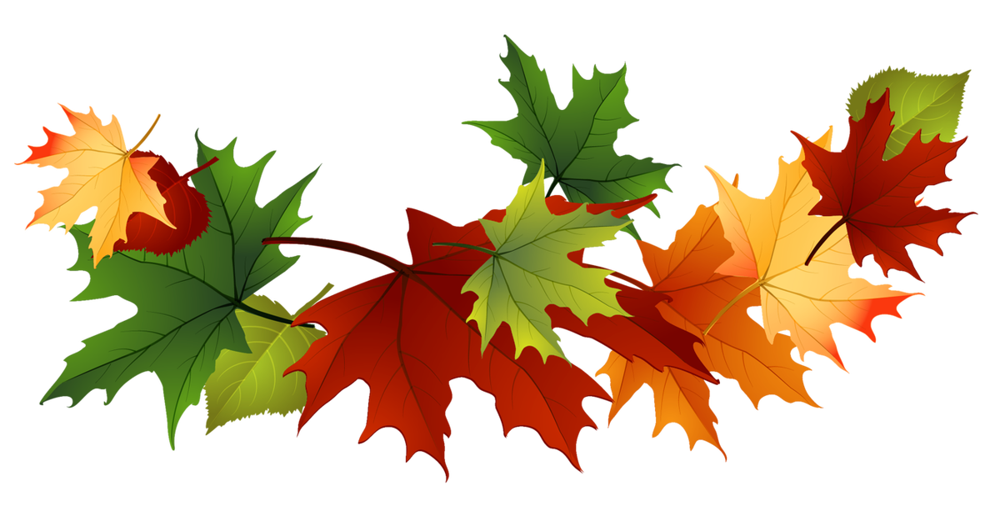  14 | 15 | 16 | 17
18 | 19  Thanksgiving Holidays | 20  Thanksgiving Holidays | 21  Thanksgiving Holidays | 22  Thanksgiving Holidays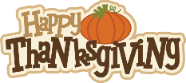 | 23  Thanksgiving Holidays | 24
25 | 26 | 27 | 28 | 29 | 30

